Name: _______________________ ID: _______________________

**Analytical Chemistry II – Quiz (16th April, 2024)**

1) Define the following terms:

phosphorescence: It is the process in which an excited molecule emits a photon while undergoing a transition from an excited triplet state to a lower state of a different spin multiplicity.

predissociation: It occurs when a molecule changes from a higher electronic state to an upper vibrational level of a lower electronic state in which the vibrational energy is great enough to rupture the bond.

2) Draw scheme of double-beam spectrofluorometer. Label all the components.

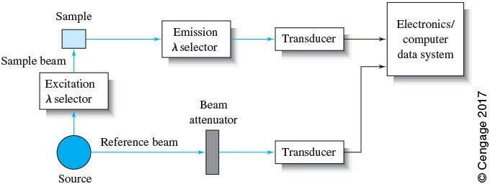

OR

